للمزيد من الملفات والحلول، تابع قناتنا على التليجرام: https://t.me/muealimuk

المملكة العربية السعودية الصف: الثاني متوسط
وزارة التعليم السنة الدراسية: الثانية
المدرسة ............................... العام الدراسي 1447 هـ
الزمن: ساعتان
الاختبار النهائي لمادة اللغة الإنجليزية – الصف الثاني متوسط – السنة الدراسية الثانية (الدور الأول) لعام 1447 هـ
عزيزتي الطالبة:
- استعيني بالله ثم اجيبي عن الأسئلة
- فضلا تأكدي من كتابة اسمك الرباعي ورقم الجلوس
- الإجابة باللون الأزرق فقط

اسم الطالبة رباعيا
رقم الجلوس: |  | الصف: الثاني متوسط | المادة: اللغة الإنجليزية
اليوم: | التاريخ: / 1 / 1448 هـ

المدققة وتوقيعها | المراجعة وتوقيعها | المصححة وتوقيعها | الدرجة كتابة | الدرجة رقما | السؤال
Guided
Composition
 |  |  |  |  | Reading Comprehension
 |  |  |  |  | Grammar
 |  |  |  |  | Vocabulary
 |  |  |  |  | Orthography
 |  |  |  | 40 | المجموع

Kingdom of Saudi Arabia 2nd Intermediate Grade
Ministry of Education Time: Two Hours
………………. Intermediate School Number of papers: 3
Final Exam – Second Term - 1447 AH
- Guided Composition:

8
Use the following word bank to write a paragraph about Your Next Vacation.
Word bank: (car – climb – family – stay – travel – visit )
_________________________________
_________________________________________________________________________________________________________________________________________________________________________________________________________________________________________________________________________________________________________________________________________________________________________________________________________________________________________________________________________________________________________________________

9
- Reading Comprehension:
Read the passage and answer the questions below:
My name is Adam. I live with my family in a big house. I have two sisters and one brother. We share many chores with our parents. My brother and I take the garbage out. We also wash our father’s car twice a week. Every Friday, I weed the garden and my brother waters the plants. I also make my bed in the morning. My sister, Emily, sweeps the floor every evening and washes the dishes after dinner. She also helps Mom with shopping every Thursday. My mother cooks for us and washes our clothes. My father fixes anything broken at home.
- Choose the correct answer:
  - Adam washes his father’s car …… times in the week.
- 1 | - 2 | - 3 | - 4
  - Adam’s …………. helps him to take out the rubbish.
- brother | - sister | - uncle | - father
  - There are ……… members in Adam’s family.
- 3 | - 4 | - 5 | - 6
  - Adam weeds the garden on ……………..
- Sunday | - Tuesday | - Thursday | - Friday
  - Emily washes the dishes after …………..
- breakfast | - lunch | - dinner | - school
  - She in line 5 refers to Adam’s ………….
a- sister | b- aunt | c- grandmother | d- cousin

- Check ( T ) or ( F ):
- Adam has one sister and two brothers. ( )
- Emily helps her mom with shopping every Monday. ( )
- Adam’s father cooks for the family every day. ( )

9
- Grammar:
- Choose the correct answer:
- Let’s ………… football.
- play | - plays | - played | - playing
- This house is …………..
- they | - them | - their | - theirs
- He put ………….. salt that we couldn’t eat it.
- so | - so many | - so much | - many
- Mona is a good cook. She cooks ………….
- good | - better | - best | - well
- …………….. colour do you prefer? Red or blue?
- How | - Which | - Who | - Where
- If you study hard, you ………… your exam.
- passed | - passes | - passing | - will pass
- The mother wants her children …………. the toys away.
- put | - puts | - to put | - putting
- I wasn’t able to ………… in the dark.
- seeing | - see | - sees | - saw
- The students ……………. a test last week.
- write | - are writing | - wrote | d- have written

- Vocabulary:

9
- Write the words under the pictures:
cage – scream – mosquito – oasis – napkin – hurricane

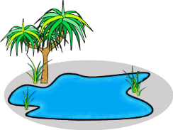
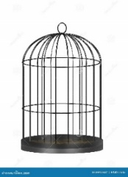
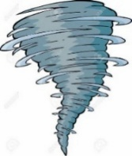
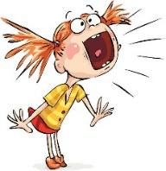
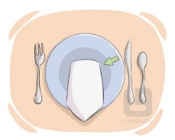

___________ ___________ ___________ ___________ ___________

- Classify the words:
babysit – fall – cheetah – earrings

Animal | Chores | Jewelery | Season

- Orthography:

5
  - Choose the correct missing letters:
- Could you lo__er your voice?
- a | - e | - o | - w
- He was sitting on a bench and listening to music through his hea__phones.
- b | - d | - p | - q
- She got st__ck in an elevator.
- a | - e | - i | - u
- Some types of ca__el have two humps and others have one.
- m | - n | - w | - f
- This game has wei__d rules.
- p | - r | - s | - t

END OF QUESTIONS
BEST OF LUCK
Ms. Tahani AlGhamdi

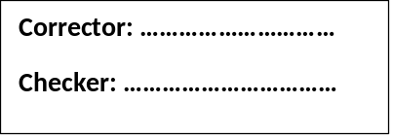

Turn the page / أقلب الصفحة
8

Q1 / Composition
Fun activities and weather
Describe the activities you do and how you feel in certain weather conditions
1. How do you feel when the weather is warm and sunny?
2. How do you feel when the weather is cloudy and rainy?
3. How do you feel when the weather is hot and sunny?

Question No. | Q1 | Q2 | Q3 | Q4 | Q5 | Total
Question’s mark | 8 | 9 | 9 | 9 | 5 | 40
Student’s mark

Super Goal 2 - English Language
2nd Intermediate Grade
Final Exam 1447 H
Time: 1.5

Kingdom of Saudi Arabia
Ministry of Education
intermediate School

9
Q2/ Comprehension

"Ship of the Desert"
Camels are known as the "Ships of the Desert". They can travel long
distances in the hot desert sand, carrying people and goods. Their humps
store fat, helping them survive without water for days. With their wide feet
and strong bodies, camels are perfect for desert travel.

- Choose the correct answer: (1 mark each)

- Why are camels called “Ships of the Desert”?
a) They can swim b) They travel long distances c) They can fly d) they drink water
- What do camels carry in the desert?
a) water b) food c) people and food d) animals
- How long can camels survive without water?
a) A few minutes b) A few hours c) many months d) A few days
- They in line 1 refer to:
a) ships b) camels c) desert d) known
- What parts of the body help camels to survive without water?
a) their humps b) their tails c) their feet d) their back

- Choose (True) or (False): (1 mark each)
- Camels are known as the "Kings of the Desert”. (True/False)
- Camels' humps store fat. (True/False)
- Camels can travel long distances in the desert. (True/False)
- Camels are not perfect for desert travel. (True/False)

d
Turn the page / أقلب الصفحة
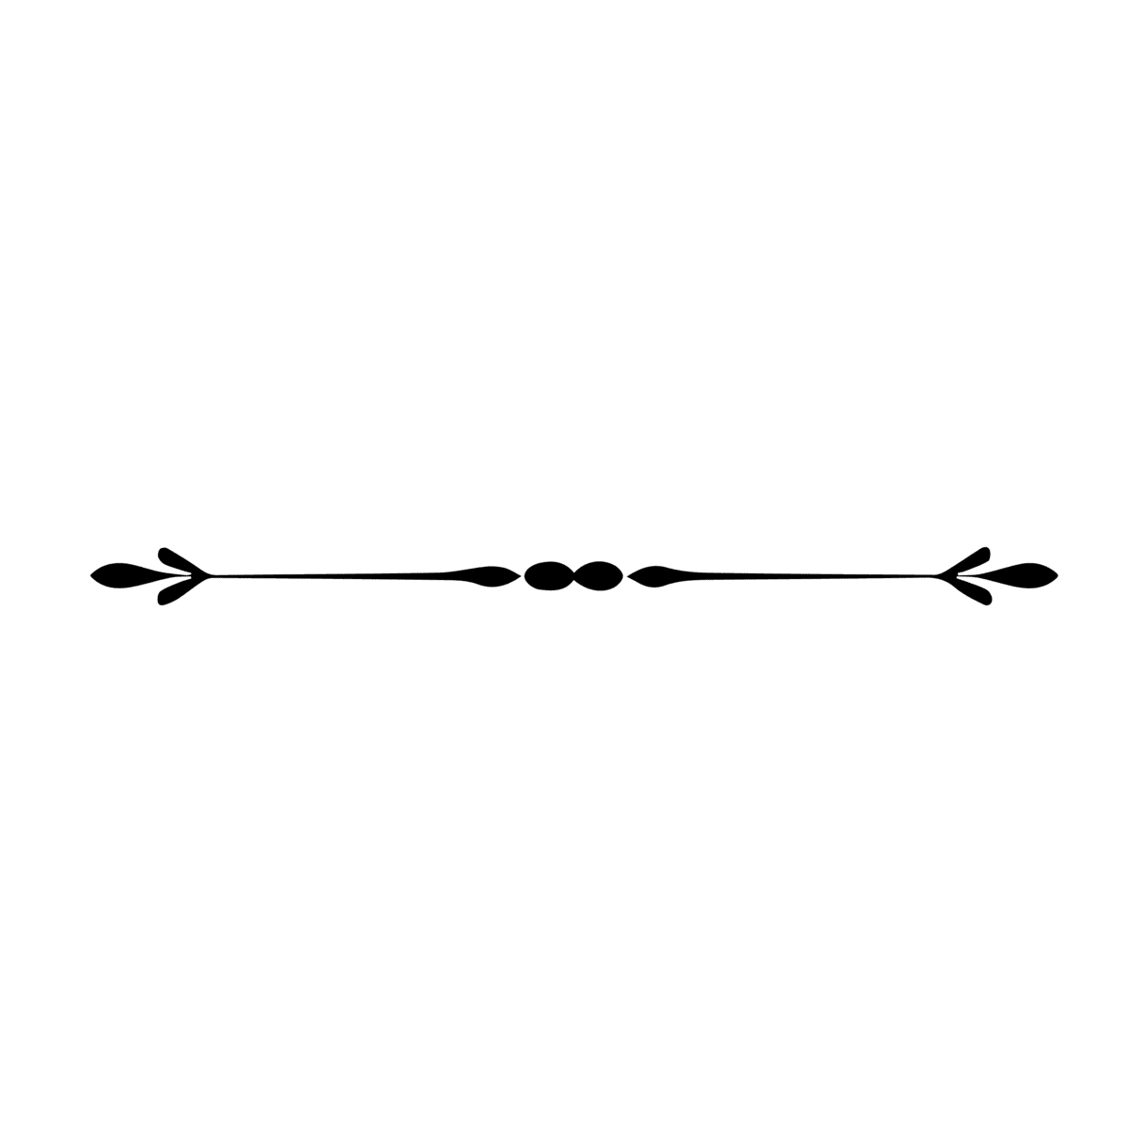
Turn the page / أقلب الصفحة
Q3/ Grammar
A/ Choose the correct answer: (½ mark each)
- They (speaks - speak - spoke - speaking) English very well.
- I go (shopping – shops– shop - shoping twice a week.
- We are (go - goes - going - went) to visit Oman.
- Please drive (careful – carefully – care – carfull).
- This pizza is (good – best – better– more) than the one we had yesterday.
- Tom hurt (himself – herself -itself-themselves) while playing football.
- If I ____ (have – has – will have – will) time, I will watch a movie tonight.
- Will you help me? (request – offer – promise – refuse).
- I (has – have – had – is) visited three different countries.
- If you heat ice, it (melt - melts - melted - melting).
B/ Do as shown between brackets: (½ mark each)
- I'm go to do my homework now. (Correct the mistake)
…………………………………………………...
- What – doing – you – are – tonight? (Rearrange)
…………………………………………………….
- Sara has visited her grandparents. (Form a negative sentence)
…………………………………………………….
- Mona /sleep/the telephone/ring. (Make sentences using when)
………………………………………………….

A/ Choose the correct answer. (½ mark each)
- Mona wears a nice ___________ around her neck.
ring | earring | necklace | bracelet
- The hotel has a ____________ bedroom with a golden door knop.
thrilling | luxurious | exotic | adventurous
- _________ is usually sunny, hot, and dry.
summer | winter | fall | spring
- She ________when she saw a spider on her bed.
sleep | play | laugh | shrieked

Q4/ Vocabulary
9
9
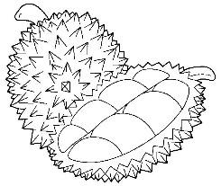

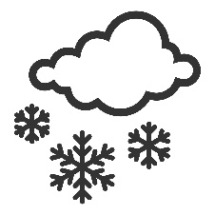
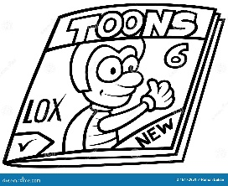
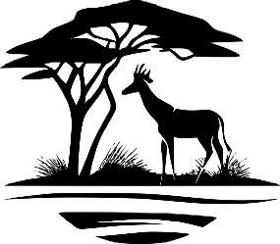
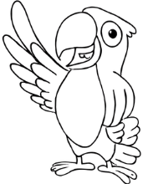
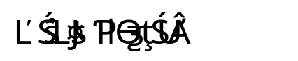
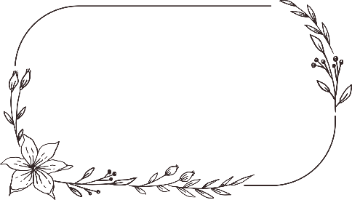
B/ Match the word with its meaning: (½ mark each)
- wound |  | disappoint someone
- let down |  | didn’t get stressed
- a blender and a microwave |  | injury
- kept my cool |  | electronics and appliances

C/ Write the correct word under each picture: (½ mark each)

D/ Circle the odd word: (½ mark each)
- fish shark lobster camel
- summer winter wind fall
- go bowling go swimming shopping wash the dishes
- suit dress blouse skirt

Q5/ Orthography

- The w__ather is very cold today. (e– i -a)
- Doing the la__ndry is my favorite chore. (w – o-u)
- ___orse is an animal like a zebra and a horse. (s -z -n)
- Dia__ond is the hardest element in the world. (m-n-h)
- Could you do me a fa__or? ( v -f – p)
5

Best wishes
By: Manal Al-Shareef

…………………………
…………………………
…………………………
…………………………
…………………………d
…………………………
magazine - thief - safari – parrot – snow – durian fruit

